Heavy Weather Sailing
RS700

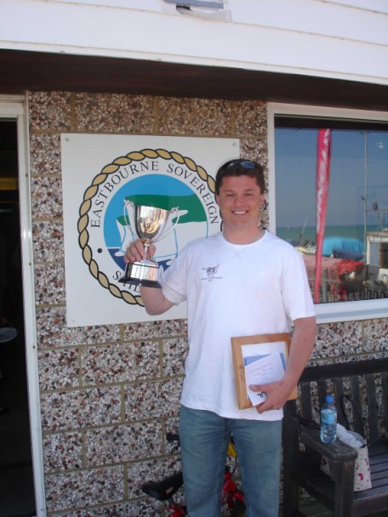
At the record breaking RS700 Nationals at Eastbourne, Paul Bayliss, 2006 National and European Champion, ran a very successful seminar for the fleet, sharing his approach to heavy weather sailing in the RS700. With the autumn gales beckoning it should make interesting reading, and there are plenty of tips for sailors from other fleets too….

Attitude and Approach

- Be confident. You need to be in control of the boat and not vice versa.
- Use controlled aggression; this is a big powerful boat which needs to be wrestled around the course in a blow.
- Give yourself more space and time to carry out any manoeuvres than you would normally plan to. Take the pressure out situations and try to relax.
- Don’t experiment with new techniques whilst racing. You should sail in the same way as you always sail in practice or club racing. Actually this applies to all wind conditions.
- Never give up – others will be struggling in harsh conditions too, and they can capsize or have a breakage at any time.
- Push the envelope in terms of conditions – if you go out in 20 knots, 15’s easy. If you can survive 25 knots, 20 knots is going to be straightforward. If you never push yourself, you’ll never learn what you’re capable of!
- Enjoy yourself and keep positive – we do this for fun!
- Make sure you’ve done plenty of Practise, Practise, Practise

Boat Set-up and Preparation

- In 15 knots or more add a bit more rake; one more hole on the shrouds is adequate. Also add more rig tension to compensate for the greater mast bend which will occur in these conditions.
- In these conditions rake the centreboard back in order to keep the boat in balance. This will also have the effect of making the tacks easier.
- Use more kicker than you can imagine possible upwind. Mark your kicker to ensure you can quickly repeat any settings either when putting the kicker on or letting it off.
- With the high kicker loads it is quite normal to have both shrouds slack at times going upwind. However if this is excessive you should add some more rig tension, or even spreader length if this is severe.
- The mainsheet strops should be set fairly long, so that with medium kicker on, you can only just get the leeward strop tight. With max kicker, you’ll never get the leeward one tight. This doesn’t matter, because you should be sailing with the main cracked off quite a lot. It goes without saying that the mainsheet strops should be equal. Check this by taking the mainsheet block forward until it touches the cockpit floor. The centreboard case should tell you if this is central or not.
- Normally there is no need to make significant changes to the lowers, the extra rake will already have effectively loosened them. However….
  - If the rig is panting, ie bending too much in the middle section, and the boat feels underpowered and isn’t pointing when you want it to, add slightly more lowers.
  - If the boat is staggering and not accelerating, particularly in the gusts, slightly reduce the lowers.
- Fit Staymasters as these are by far the easiest, quickest and safest way to adjust your lowers on the water. At most you need to adjust these by +/- 0.5 from your normal setting
- Lubricate everything which moves. This is more critical than normal due to the higher loads involved.
- Keep the boat well maintained, a breakage is more likely on a windy day and can result in more serious consequences as well as losing the race.
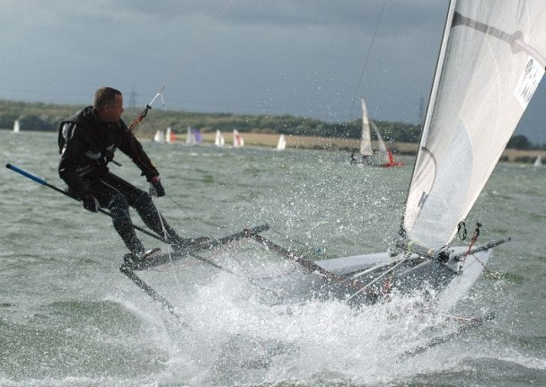

Sailing the Race

- Fully commit to every manoeuvre, backing off and sailing too cautiously normally creates more problems than it avoids.
- Always fly the kite as the boat is more stable downwind with it up, even in survival conditions sat on the rack!
- You can also trapeze with the back foot on the gunwale or intermediates if you have them fitted. This really locks you onto the boat in rough conditions.
- Don’t oversheet the main downwind.
- Avoid other boats and concentrate on sailing the boat fast.
- Drop the kite early and safely to avoid any problems at the leeward mark. Single sail trapezing into the mark doesn’t lose you much distance in these conditions.
- If you’ve overstood the leeward mark, don’t be afraid of tacking round rather than doing the bear-off and gybe. You lose little time in this situation and take a lot of risk out of the manoeuvre.
- Upwind, always keep the boat moving at speed. Bear away to gain some speed before working the boat up to point higher. Don’t steer in a straight line!
- Avoid driving into waves downwind - focus on trying to
  - steer round them, or ..
  - slow the boat by bearing off, or..
  - depowering the kite by letting the luff curl momentarily or oversheeting.
- Always let the kicker and Cunningham off before the windward mark, but not too much as it is easy to death roll. Have marks on the standing part of the kicker so that you know how much to let off.
- Go into gybes fast, you’ve probably got 20 seconds from coming into the boat till the boat slows and a slow gybe will be wet! Make sure you dump the main before the gybe and in the toughest conditions focus on simply getting through the gybe and sorting the mess afterwards.

Good sailing.

Ian Nolan and Paul Bayliss

